NOISE POLLUTION SYSTEM

OVERVIEW:

Sound and air pollution are a prominent subject that in our country continues to be highlighted every year. The air quality index (AQI)in certain sections of the nation exceeds 100 decibel. Air quality and sound amplitude must e monitored for a better and safer life for everybody.

NEED OF PROJECT:

1. The air and sound pollution is increasing abruptly
2. To maintain its monitoring is essential
3. This system allows us to detect sound and air pollution levels over and over based on IOT

PROBLEM STATEMENT:

The air and sound pollution is a growing issue these days. As an engineer what is low cost and effective ways to measure this pollution and encourage community to take certain steps to reduce it to reasonable limit?

COMPONENTS SELECTIONS:

1. Arduino uno – it is a microcontroller. It is based on ATmega328P
2. MQ135 gas sensor(sno2)- which has lower conductivity in clean air. Sulphide and benze steam also sensitive to smoke and other harmful gases.
3. ESP8266 Wifi module – it is an low cost wifi module that enables an existing microcontroller project to be supplied with wi-fi capabilities.
4. Sound sensor – microphone sound sensor that measure high decibel sounds.
5. LCD displays.

BLOCK DIAGRAM:

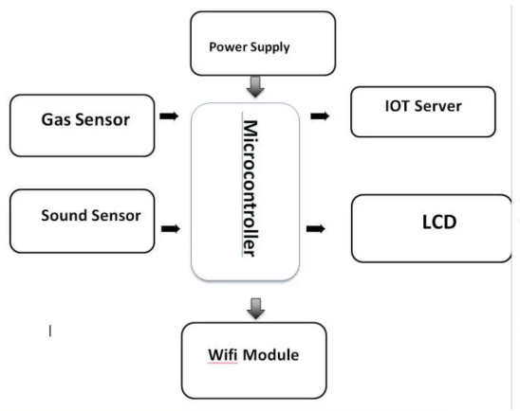

SCHEMATIC:

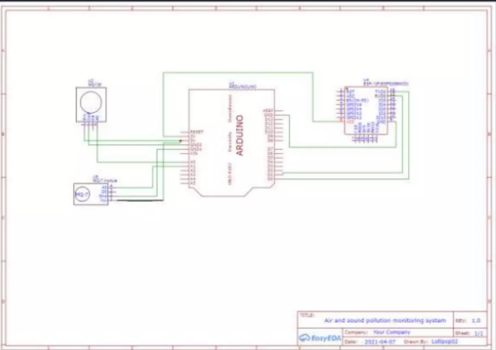

LAYOUTS:

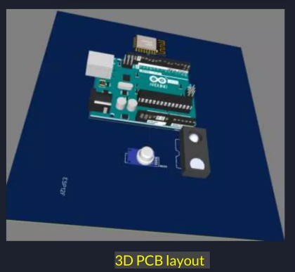

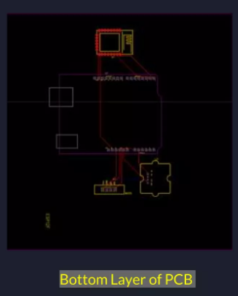

SIMULATION RESULTS:

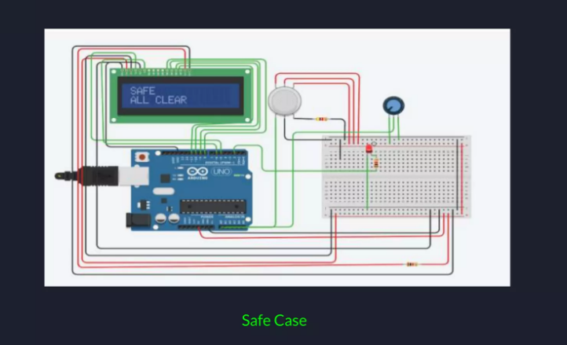

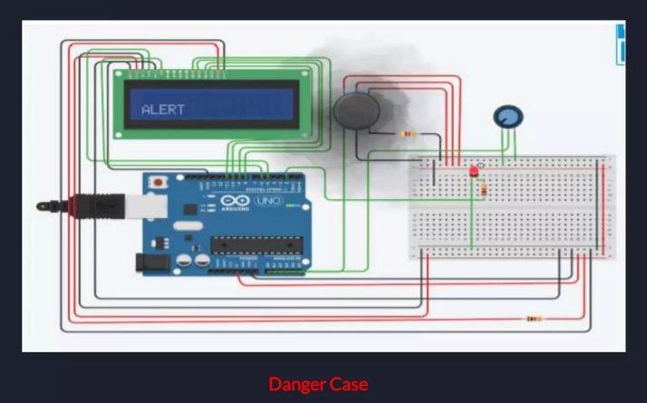

ENCLOSURE:

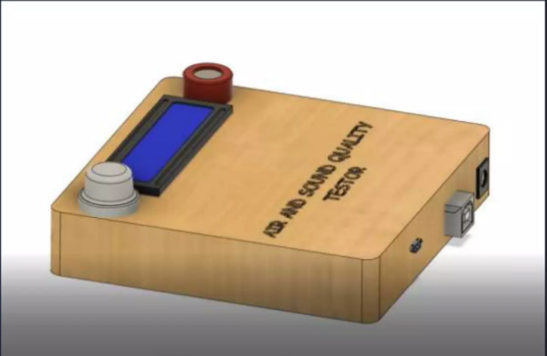

FUTURE SCOPE:

* The IOT based air and sound pollution monitoring device is a great step towards a healthy livelihood. With the help of this device not only the municipal authorities but even the common people can participate in the process of controlling pollution and ensure safe environment.
* We will work on displaying the amount of poisonous gases detected by sensor.
* Since with time the upgrade in sensor will take place such as range of detection.